A

Mini Project Report on

#### EXAM PREPARATION SITE

Submitted in partial fulfillment of the requirements for the degree of

BACHELOR OF ENGINEERING

IN

**Computer Science & Engineering**

Artificial Intelligence & Machine Learning by

Sagar Mane :- 23106032

Rajanya Kshatriya:- 23106096

Bhagya Gandhi:- 23106101

Sarvesh Bhartu:- 23106055

Under the guidance of

#### Prof. Monali Korde

**Department of Computer Science & Engineering**

**(Artificial Intelligence & Machine Learning)**

**A. P. Shah Institute of Technology**

**G. B. Road, Kasarvadavali, Thane (W)-400615**

**University Of Mumbai**

**2024-2025**

#### CERTIFICATE

This is to certify that the project entitled “**UPSC EXAM PREPARATION SITE”** is a bonafide work of Sagar Mane (23106032), Rajanya Kshatriya (23106096), Bhagya Gandhi (23106101), Sarvesh Bhartu (23106055) submitted to the University of Mumbai in partial fulfillment of the requirement for the award of **Bachelor of Engineering** in **Computer Science & Engineering (Artificial Intelligence & Machine Learning).**

|  |  |  |
| --- | --- | --- |
|  |  |  |
| Prof. Monali Korde |  | Dr. Jaya Gupta |
| Mini Project Guide |  | Head of Department |

#### Project Report Approval

This Mini project report entitled “**UPSC EXAM PREPARATION SITE*”*** by **Sagar Mane, Rajanya Kshatriya, Bhagya Gandhi and Sarvesh Bhartu** is approved for the degree of **Bachelor of Engineering***in* **Computer Science &Engineering***,* (AI&ML) **2024-25**.

External Examiner:

Internal Examiner:

Place: APSIT, Thane Date:

**Declaration**

We declare that this written submission represents my ideas in my own words and where others' ideas or words have been included, I have adequately cited and referenced the original sources. I also declare that I have adhered to all principles of academic honesty and integrity and have not misrepresented or fabricated or falsified any idea/data/fact/source in my submission. I understand that any violation of the above will be cause for disciplinary action by the Institute and can also evoke penal action from the sources which have thus not been properly cited or from whom proper permission has not been taken when needed.

|  |  |  |  |
| --- | --- | --- | --- |
| Sagar Mane | Rajanya Kshatriya | Bhagya Gandhi | Sarvesh Bhartu |
| (23106032) | (23106096) | (23106101) | (23106055) |

##### ABSTRACT

The Union Public Service Commission (UPSC) exam is one of India’s most competitive and challenging assessments, requiring aspirants to demonstrate in-depth knowledge and strategic planning. Our UPSC Exam Preparation Platform is designed to provide a comprehensive and structured learning experience, utilizing advanced e-learning technologies to make resources accessible and effective for learners at all levels. The platform offers daily current affairs updates, mock tests, previous years’ question papers, and syllabus tracking tools, ensuring thorough preparation for both the Preliminary and Mains stages. It also provides optional subject-specific resources, catering to individual needs with in-depth materials tailored to specific areas. A key feature of the platform is its AI-driven recommendations, which adapt to each learner’s style, progress, and strengths, while personalized dashboards allow users to track their performance and focus on areas that need improvement. The platform’s online format ensures that students can access study materials anytime and anywhere, removing time and geographical barriers especially for working professionals or those in remote locations. This UPSC Exam Preparation Platform integrates modern e-learning tools to provide a holistic approach to exam preparation, making it easier for aspirants to stay on track, improve their knowledge, and excel in the UPSC exams.

**Index**

|  |  |
| --- | --- |
| Index | Page no. |
| Chapter-1 |  |
| Introduction 1 | |
| Chapter-2 |  |
| Literature Survey 3 | |
| Chapter-3 |  |
| Problem Statement 7 | |
| Chapter-4 |  |
| Experimental Setup 9 | |
| Chapter-5 |  |
| Proposed system and Implementation 11  Chapter-6  Future scope 17 | |
| Chapter-7 |  |
| Conclusion 20  References 21 | |

# CHAPTER 1 INTRODUCTION

# INTRODUCTION

The Union Public Service Commission (UPSC) examination stands as one of the most prestigious and demanding competitive exams in India. With its extensive syllabus, rigorous evaluation process, and unpredictable nature, it requires aspirants to demonstrate exceptional knowledge, analytical ability, and time management skills. For many aspirants, the journey to cracking the UPSC exam can be overwhelming due to the vastness of the syllabus, the need to stay updated on current affairs, and the pressure to efficiently manage their study schedule.

To address these challenges, our UPSC Exam Preparation Platform is designed to provide a comprehensive, accessible, and effective solution for aspirants at every stage of their preparation.The platform offers a wide range of resources, including daily current affairs updates, mock tests, previous years’ question papers, and detailed syllabus tracking, ensuring aspirants have everything they need to succeed. By offering subject-specific resources for both General Studies and optional subjects, the platform ensures a focused and deep dive into each subject area, essential for success in the exam.

A standout feature of the platform is the use of AI-driven technology that personalizes the learning experience based on individual strengths, weaknesses, and progress. Personalized dashboards help candidates track their performance, set goals, and identify areas that need more attention. This level of customization makes it easier for each aspirant to tailor their preparation strategy according to their unique learning style and needs. Additionally, the flexibility of online learning ensures that aspirants can study from anywhere, at any time, overcoming constraints related to geography or time.

With the growing reliance on e-learning in today’s digital age, this platform aims to provide a modern, efficient, and user-friendly way to prepare for the UPSC exams.

By combining the power of technology with structured, quality content, the platform helps students stay organized, focused, and motivated, ensuring they are well-prepared to tackle the UPSC exam with confidence. Whether starting their preparation or fine-tuning their strategy, the platform serves as an essential tool for every aspirant aiming to succeed in one of India’s most prestigious examinations.

2

# CHAPTER 2 LITERATURE SURVEY

1. **LITERATURE SURVEY**

**History:**

The concept of online exam preparation has evolved significantly with advancements in technology and the increasing accessibility of digital education. Initially, aspirants relied on traditional methods like textbooks, coaching centers, and self-study. With the rise of the internet, various websites and online forums emerged, providing study materials and current affairs updates. Over time, platforms started offering recorded lectures, e-books, and online test series. However, these solutions lacked personalization and efficient tracking of progress. The integration of AI and data-driven analytics in education has opened new possibilities, leading to the development of intelligent exam preparation apps. Our project builds on this evolution by offering a structured, AI-enhanced platform that provides personalized study plans, quizzes, mock tests, and real-time progress tracking, ensuring a more efficient and user-friendly preparation experience.

**Literature Review :**

**1.** **Gamification and AI: Enhancing User Engagement through Intelligent Systems -Carlos J. Costa, Joao Tiago Aparicio, Manuela Aparicio, Sofia Aparicio (2024)**

This paper explores how artificial intelligence (AI) can enhance gamification techniques to improve user engagement in learning platforms. It discusses AI-driven personalization, which adapts game mechanics based on user behavior to make learning more effective. The study highlights predictive analytics for understanding engagement patterns and optimizing gamified learning experiences. However, the paper also addresses challenges related to implementation complexity and the need for continuous monitoring to ensure AI-driven gamification remains effective.

**2. Adaptive Learning Using Artificial Intelligence in e-Learning: A Literature Review - Ilie Gligorea , Marius Cioca, Romana Oancea, Andra-Teodora Gorski, Hortensia Gorski and Paul Tudorache (2024)**

This literature review examines the impact of artificial intelligence in adaptive learning environments, focusing on how AI-driven models personalize educational experiences. It evaluates existing studies on AI-based recommendation systems, real-time feedback mechanisms, and intelligent tutoring systems. While the paper highlights the benefits of AI in enhancing student

learning outcomes, it also points out the lack of large-scale empirical studies and the need for more robust AI models to improve accuracy.

**3.** **Gamified AI-Driven Assessments - Namya Joshi , Monica Joshi (2024)**

The paper explores the integration of gamification with AI-driven assessment systems to improve student motivation and learning outcomes. It discusses the advantages of AI-powered adaptive assessments, which adjust difficulty levels based on learner performance. Additionally, the study highlights the role of interactive elements, such as leaderboards and rewards, in increasing student engagement. However, it also notes potential biases in AI models and the need for a strong infrastructure to support AI-based gamification.

**4. Leveraging AI in E-Learning: Personalized Learning and Adaptive Assessment through Cognitive Neuropsychology—A Systematic Analysis - Constantinos Halkiopoulos and Evgenia Gkintoni (2024)**

This systematic analysis focuses on how AI enhances personalized learning and adaptive assessments through cognitive neuropsychology. The paper discusses AI’s role in tailoring educational content based on learners' cognitive abilities, optimizing instruction delivery. It emphasizes adaptive testing mechanisms that dynamically adjust based on student responses. However, the study also raises concerns about ethical implications, AI biases, and the potential risk of excessive dependency on AI for learning.

**5. Analyzing the Impact of Gamification Techniques on Enhancing Learner Engagement, Motivation, and Knowledge Retention: A Structural Equation Modeling Approach - Lassaad Smirani and Hanaa Yamani (2024)**

This study investigates how gamification techniques influence learner engagement, motivation, and knowledge retention using a structural equation modeling approach. It presents empirical evidence on the effectiveness of gamification in improving learning outcomes and analyzes factors that contribute to sustained motivation in educational environments. The research identifies key benefits of gamified learning but also points out that excessive competition and a one-size-fits-all approach may not cater to diverse learning needs.

# CHAPTER 3

## PROBLEM STATEMENT

**3. Problem Statement**

UPSC aspirants face challenges in managing their preparation due to the vast syllabus, lack of structured resources, and difficulty in tracking progress. Traditional methods are rigid, and existing platforms do not offer AI-driven assistance or personalized learning. Our exam preparation app provides a seamless solution with features like a login system, exam and subject selection, an AI chatbot for guidance, quizzes, previous years' questions (PYQs), and mock tests for performance tracking. This platform ensures an organized, efficient, and personalized study experience for aspirants.

# CHAPTER 4

## EXPERIMENTAL SETUP

###### 4. Experimental Setup

1. **Platform Development:**
   * Design and develop a web-based platform accessible via both desktop and mobile devices.
   * Integrate essential features such as daily current affairs updates, mock tests, previous years' question papers, and syllabus tracking.
2. **Content Creation and Curation:**
   * Collect and organize study materials for both General Studies and optional subjects.
   * Update the platform with current affairs from reliable news sources daily.
   * Ensure the availability of detailed, subject-specific resources, including video lectures, notes, and practice questions.
3. **AI Integration:**
   * Develop and integrate AI algorithms to recommend personalized study plans based on individual progress, strengths, and weaknesses.
   * Use AI to suggest mock tests, articles, and video content aligned with the user's learning pace and requirements.
4. **User Interface and Experience:**
   * Create user-friendly dashboards for each aspirant, displaying progress tracking, performance analytics, and recommended study resources.
   * Ensure smooth navigation and accessibility of all content across devices (laptops, smartphones, tablets).

# CHAPTER 5

## PROPOSED SYSTEM & IMPLEMENTATION

**5. Proposed System and Implementation**

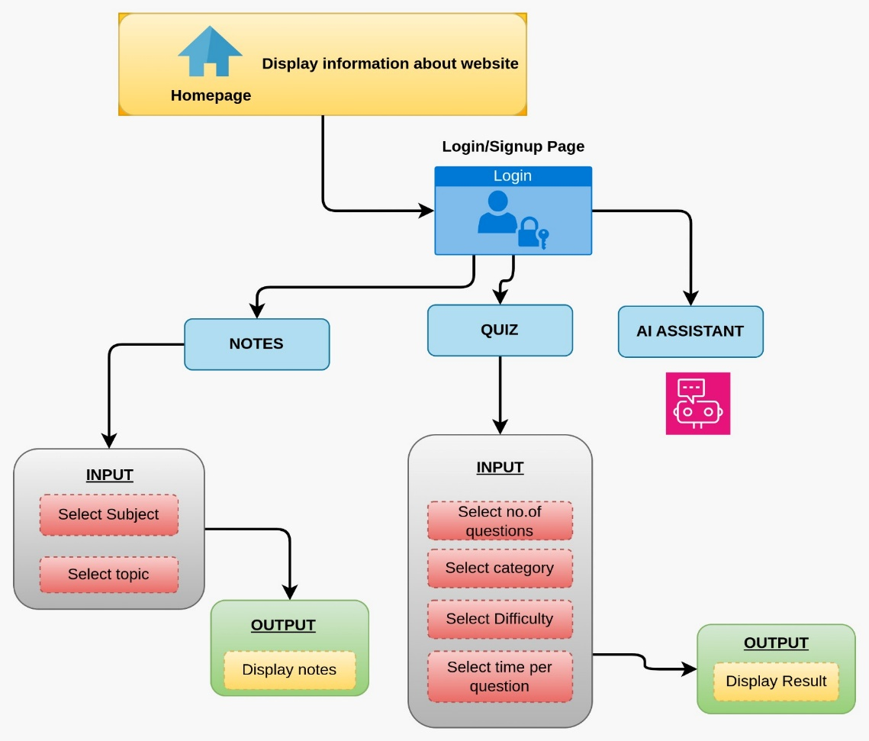

**Fig. 1 : Block diagram of proposed system**

**Description of the Block diagram :**

1. Homepage
   * Displays general information about the website.
2. Login/Signup Page
   * Users must log in or sign up to access the platform.
3. Main Features
   * Notes Section:
     + Users can select a subject and a topic.
     + The system fetches and displays relevant study materials.
   * Quiz Section:
     + Users choose the number of questions, category, difficulty level, and time per question.
     + After completing the quiz, the results are displayed.
   * AI Assistant:
     + Provides assistance and answers user queries using AI technology.

**Implementation :**

1. Frontend Development (UI/UX)

* Building the graphical user interface (GUI) with HTML for structure, CSS for styling and Javascript for interactivity, ensuring simplicity and responsiveness.

2. Backend Development

* Using PHP which Handles the backend by processing data, managing user authentication, and interacting with MySQL, ensuring robustness and compatibility across platforms.
* Implement a REST API for communication between frontend and backend.

3. Database

* Using MySQL which Acts as the database to store and retrieve user credentials.

4. AI Assistant

* Implement OpenAI GPT API to answer user queries.

5. Deployment

For deployment, we are using XAMPP, which includes:

* Apache (Web Server) → Hosts and serves your website.
* MySQL (Database Server) → Stores user credentials, progress, and study materials.
* PHP (Backend Processing) → Handles authentication, database interactions, and dynamic content.



**Fig. 2 : REGISTER/LOGIN PAGE**

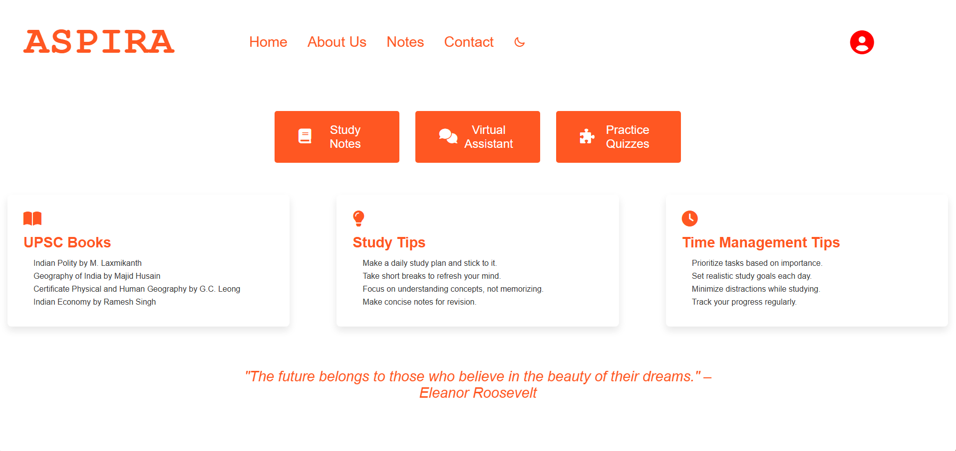

**Fig. 3 : HOMEPAGE**

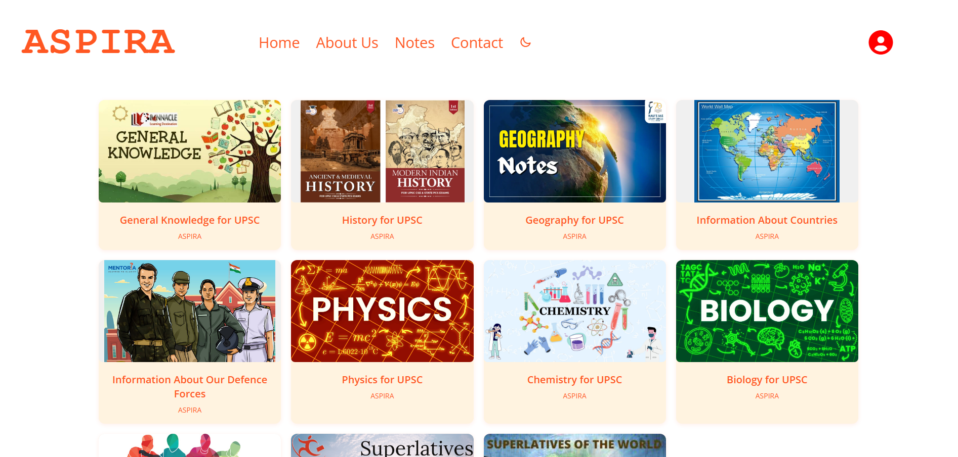

**Fig. 4 : NOTES SECTION**



**Fig. 5 : GEOGRAPHY SECTION**



**Fig. 6 : AI CHATBOT**

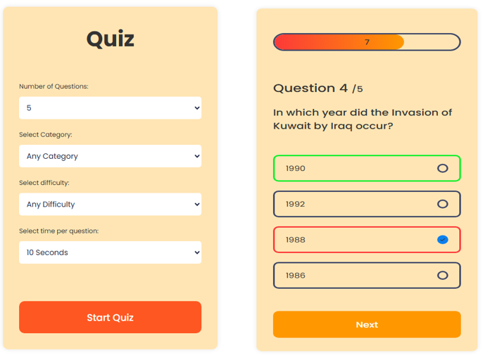

**Fig. 6 : QUIZ SECTION**

# CHAPTER 6

## FUTURE SCOPE

**Future Scope**

The future scope of this exam preparation app includes expanding its features to cover multiple competitive exams beyond UPSC, making it a versatile learning platform. AI-driven recommendations can be further enhanced to provide adaptive learning paths based on user performance and weak areas. Integration of live doubt-solving sessions, mentorship programs, and peer discussion forums can improve engagement and collaborative learning. Gamification elements like leaderboards and rewards can boost motivation. Additionally, incorporating regional language support and accessibility features will make the platform more inclusive. Advanced analytics for performance insights and predictive success rates can further refine aspirants' preparation strategies.

# CHAPTER 7

## CONCLUSION

###### Conclusion

The UPSC exam demands extensive knowledge and strategic preparation, and traditional methods often lack flexibility and personalization. This platform offers a modern, digital solution by providing structured study materials, current affairs updates, mock tests, and personalized learning paths. With AI-driven recommendations and progress tracking, the platform helps aspirants tailor their preparation to individual needs, ensuring efficient study. The flexibility of online learning further allows access to resources anytime, anywhere. Ultimately, this platform enhances the UPSC preparation experience, empowering candidates to succeed in their exam journey.

###### References

[1] Gamification and AI: Enhancing User Engagement through Intelligent Systems -Carlos J. Costa, Joao Tiago Aparicio, Manuela Aparicio, Sofia Aparicio (2024)

<https://drive.google.com/file/d/1EuF_fT43h20ok2wMkFB2FGsgQVVcTEh_/view?usp=drive_link>

[2] Adaptive Learning Using Artificial Intelligence in e-Learning: A Literature Review - Ilie Gligorea , Marius Cioca, Romana Oancea, Andra-Teodora Gorski, Hortensia Gorski and Paul Tudorache (2024)

<https://drive.google.com/file/d/1UMRUOXfz8PkZzffbKYi9Yr-C4Cu1t1VW/view?usp=drive_link>

[3] Gamified AI-Driven Assessments - Namya Joshi , Monica Joshi (2024)

<https://drive.google.com/file/d/1yBbOR6ffz0DT5AWzpjeLdwy7A2SYxhOA/view?usp=drive_link>

[4] Leveraging AI in E-Learning: Personalized Learning and Adaptive Assessment through Cognitive Neuropsychology—A Systematic Analysis - Constantinos Halkiopoulos and Evgenia Gkintoni (2024)

<https://drive.google.com/file/d/1QdD1uXSLoSyDKS5V5dS9ToipkocNyF_r/view?usp=drive_link>

[5] Analyzing the Impact of Gamification Techniques on Enhancing Learner Engagement, Motivation, and Knowledge Retention: A Structural Equation Modeling Approach - Lassaad Smirani and Hanaa Yamani (2024)

<https://drive.google.com/file/d/18xmyvHehW6b_d8mVt40h4dmvlYbKZT14/view?usp=drive_link>